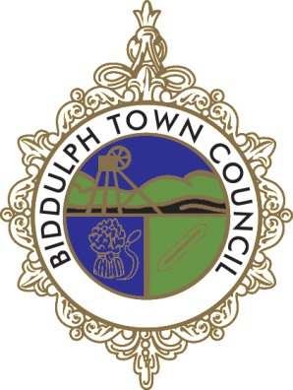
Biddulph Town Council

GRANT EVALUATION FORM 2021-2022

Biddulph Town Council aims to monitor the success and impact of every grant awarded from our funds.

It is from evaluations that we learn about the groups we fund and how successful projects have been. This knowledge helps us to be accountable and to consistently improve our grant-making processes.

We need to know the impact that your activities have had on the people living within Biddulph. Please provide a candid assessment of the challenges and success/failure of your programme or project.

Grant evaluations are so important to us that we will not fund a group again if they have not returned previous evaluations.

Please use this form if you were in receipt of a Town Council Grant and/ or a Town Councillors’ Community Grant Fund allocation.

1 Name of Group:

2 What type of Group or Organisation are you?

- Voluntary or Community
- School (voluntary, e.g. PTFA)
- Business
Other:

3 What are the main aims of the group?

4 How much grant did you receive?

5 Were you able to spend the grant within 6 months of receipt?

Yes No

If you answered ‘No’, please include details below

6 Please provide a brief summary of the activities/ events that were funded using grant monies.

7 Who benefited from the grant and how? We are asking for this detail to help understand the spread of our funding.

(Please include approximately how many people benefited and the age of these individuals- e.g. retirement, school age, toddlers. Also consider whether those that benefited came from a particular ethnic background, their sexuality and whether the project supported those with a disability).

8 Please tell us how the process could be improved for 2022-2023

