**88**

|  |  |
| --- | --- |
| Site | Stoneyfields Green Space |
| Grid Reference / Post Code | 53.119184, -2.140956  ST8 7NB |
| Brief Description | Grassed area in the centre of a housing estate, providing important green buffer between housing developments. |

|  |  |  |
| --- | --- | --- |
| Criteria |  |  |
| Location *In reasonably close proximity to the community it serves* | **√** | In the middle of a busy residential area. |
| Local Significance *Demonstrably special to a local community and holds a particular local significance, for example because of its beauty, historic significance, recreational value (including as a playing field), tranquility or richness of its wildlife.* | **√** | Area that promotes social well-being within the community. Vital amenity for the village. |
| Size, Scale *Local in character and is not an extensive tract of land*. | **√** | Small area with some trees. |
| Recommendation |  | Suitable for Local Green Space Designation |

**Picture:**

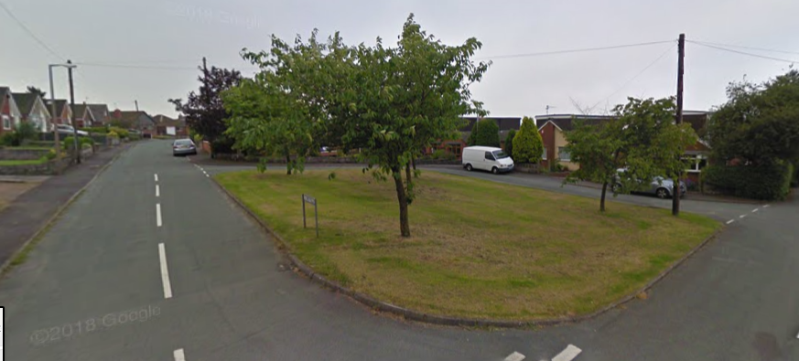

**Map:**

: