**77.**

|  |  |
| --- | --- |
| Site | **Brook Street Green Space** |
| Grid Reference / Post Code | 53°06'10.2"N 2°11'17.4"W |
| Brief Description | Small green spaces off brook street; one site with raised beds and a long flower bed, looked after and planted by local residents with help from Biddulph in Bloom. |

|  |  |  |
| --- | --- | --- |
| Criteria. |  |  |
| Location *In reasonably close proximity to the community it serves* | **√** | This green space is beside the pavement in Brook Street, with no barriers between. |
| Local Significance *Demonstrably special to a local community and holds a particular local significance, for example because of its beauty, historic significance, recreational value (including as a playing field), tranquility or richness of its wildlife.* | **√** | Small ‘breathing space’ in a largely terraced community.  A small birch tree was recently planted by residents to support a ‘poppy net’ as part of centenary remembrance. The raised beds are planted by the residents’ association, with support from Biddulph in Bloom.  Evidence of wildlife and good visual attractiveness. |
| Size, Scale *Local in character and is not an extensive tract of land*. | **√** | Size of large allotment sites. |
| Recommendation |  | Suitable for Local Green Space Designation |

Pictures:

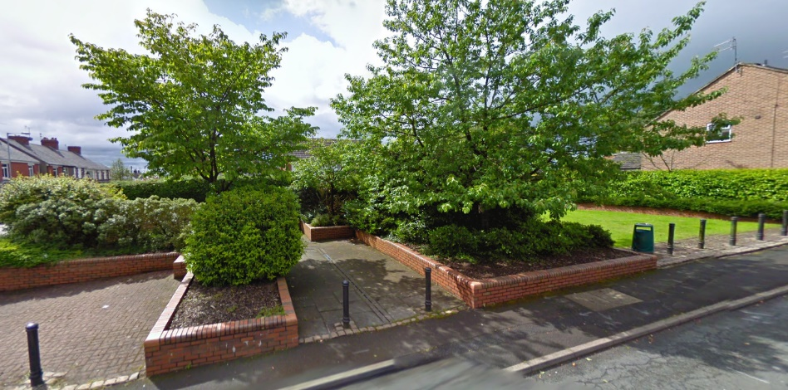

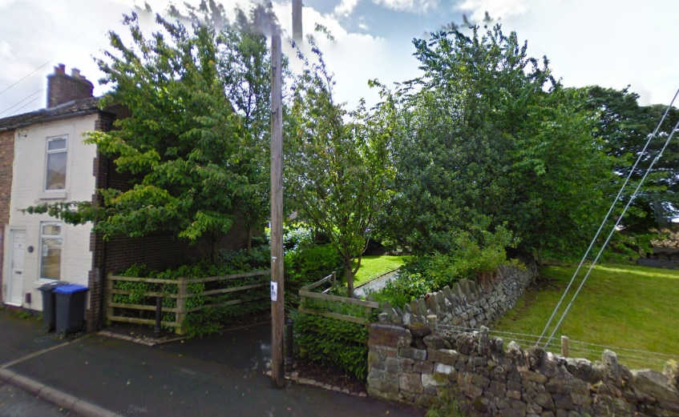

Map:

