**62.**

|  |  |
| --- | --- |
| Site | **Craigside green areas** |
| Grid Reference / Post Code | 53°07'06.0"N 2°10'35.2"W  ST8 6BL |
| Brief Description | Accessible open space providing an important transition area between settlements. |

|  |  |  |
| --- | --- | --- |
| Criteria. |  |  |
| Location *In reasonably close proximity to the community it serves* | **√** | Accessible to entire community with evidence of good informal uses, including children playing and dog walking. |
| Local Significance *Demonstrably special to a local community and holds a particular local significance, for example because of its beauty, historic significance, recreational value (including as a playing field), tranquility or richness of its wildlife.* | **√** | Recreational value. Provides visual break and transition space in a busy settlement area.  Good visual attractiveness contributing to the setting of the local area. |
| Size, Scale *Local in character and is not an extensive tract of land*. | **√** |  |
| Recommendation |  | Suitable for Local Green Space Designation |

Pictures:

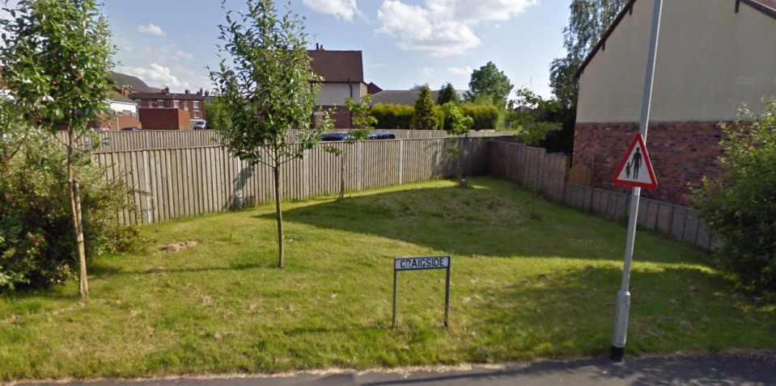

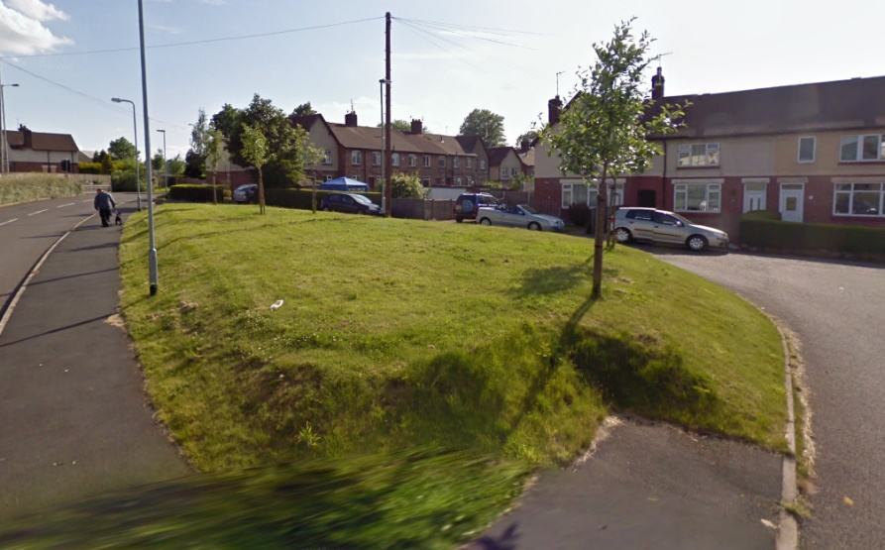

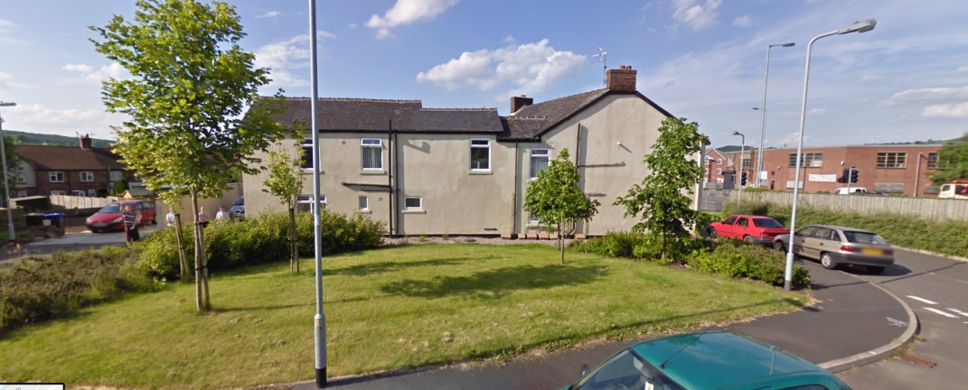

Map:

