6.
Site | Fold Lane Gateway to the Town
Grid Reference / Post Code | SJ888, 595
Brief Description | The grass verges are on the junction of Fold Lane with Congleton Road. Biddulph in Bloom volunteers perform this voluntary work regardless of whether the town is putting an entry into the competition or not. Therefore, it is an endeavour done by the people of the town, for the people of the town. This is a particularly good example (by Biddulph in Bloom) and provides a beautiful passageway into the town from the north.

Criteria.
Location  In reasonably close proximity to the community it serves | √ | It is 2 triangular grass verges by the main road side. There is a seating bench on the site which allows for quiet appreciation of the planting. It provides a pleasant entrance to the town from the north.
Local Significance  Demonstrably special to a local community and holds a particular local significance, for example because of its beauty, historic significance, recreational value (including as a playing field), tranquility or richness of its wildlife. | √ | This work has been being carried out on a voluntary basis by the people of the town for more than 20 years. It is hugely valued by the people of the town and its visitors. This work is carried out throughout the year and these grass verges in particular are very well maintained. On entering the town these planted verges reinforces Biddulph’s reputation as the “Garden Town of Staffordshire”. Throughout the spring, summer and autumn months pollinators are supported by this planting and we should ensure it is not lost to them or to the people of Biddulph.
Size, Scale  Local in character and is not an extensive tract of land. | √ | This is not an extensive tract of land being equivalent to a small front garden in size. It has importance to the locality in that it reminds Biddulph and its visitors that the town is home to the best example of the Victorian Garden in the country (according to Alan Titchmarsh!)
Recommendation | √ | Suitable for Local Green Space Designation

Pictures:

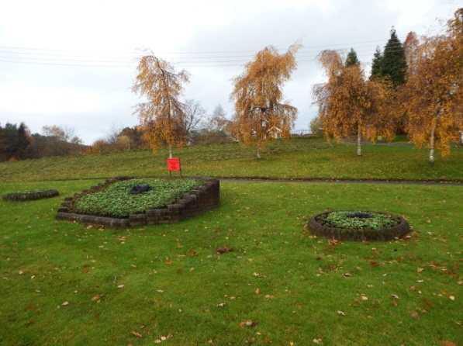 | 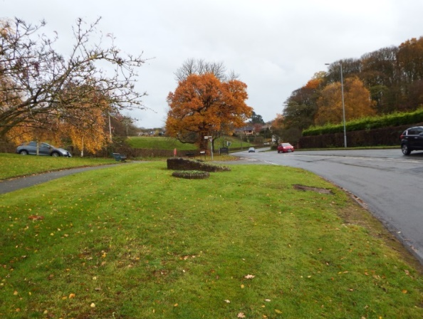
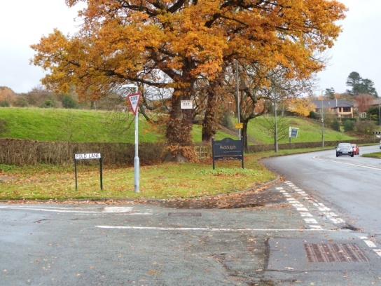
Map:

