56.
Site | VOS 12- ‘Halls Road’  Known locally as Field View (west) and Briarswood
Grid Reference / Post Code | SJ 88521 58312
Brief Description | This site forms an important natural wildlife corridor along the Biddulph Brook.

Criteria.
Location  In reasonably close proximity to the community it serves | √ | Within the town centre. A path leads through the woodland and over the river linking Halls Road to Briarswood and the town centre.
Local Significance  Demonstrably special to a local community and holds a particular local significance, for example because of its beauty, historic significance, recreational value (including as a playing field), tranquility or richness of its wildlife. | √ | Biodiversity: An important wildlife corridor along the river.  Local community: Children play in the woodlands (evidenced by rope swings).
Size, Scale  Local in character and is not an extensive tract of land. | √ | c.2.7 acres in total.
Recommendation |  | Existing Local Green Space Designation within the Local Plan
Pictures:

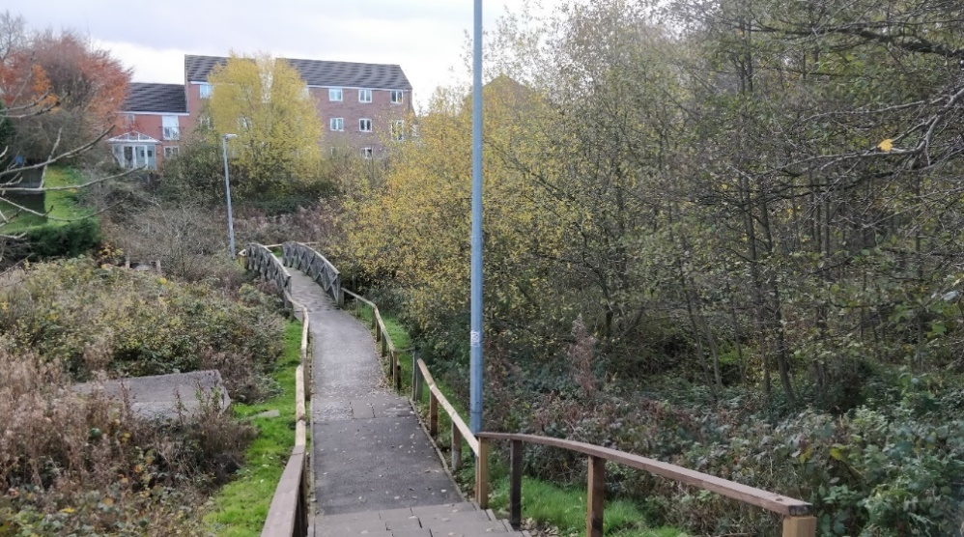
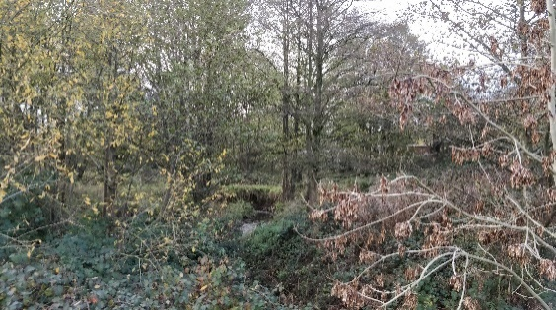 | 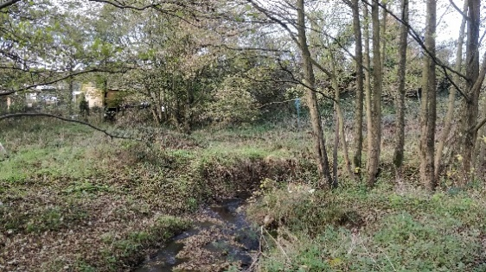
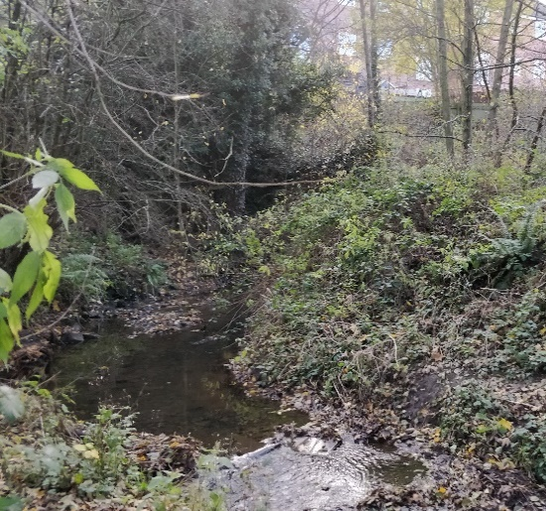 | 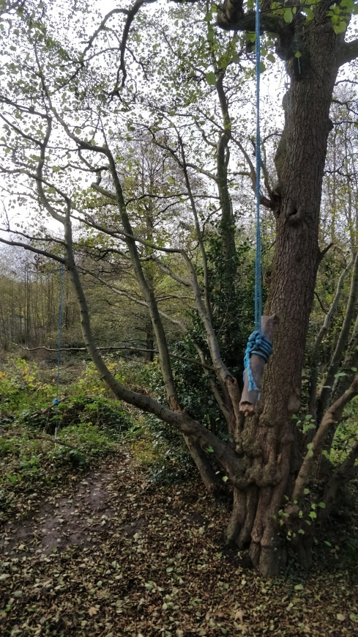
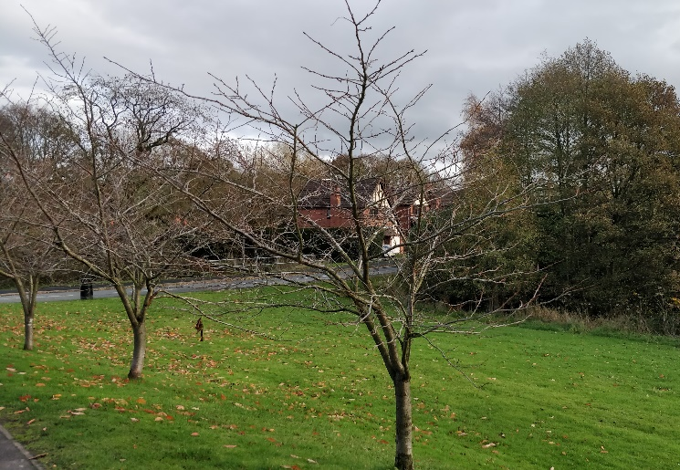

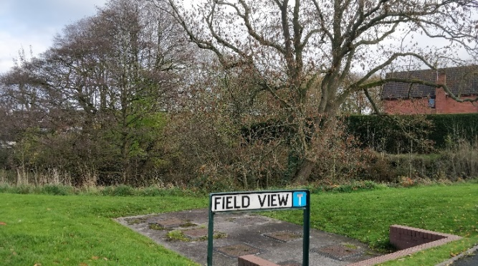

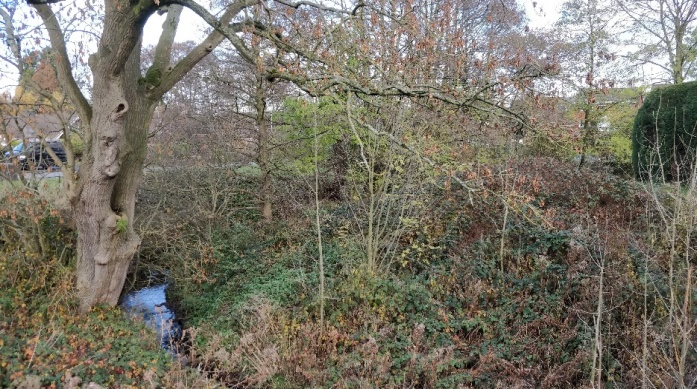

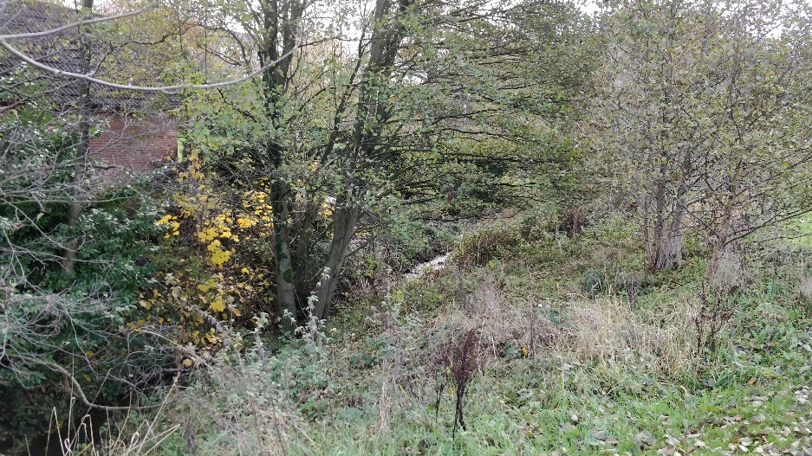

Map:

Page 2 Halls Road

