**45.**

|  |  |
| --- | --- |
| Site | **Hawthorn Grove Play Area** |
| Grid Reference / Post Code | 53°06'39.3"N 2°09'48.7"W  ST8 6UJ |
| Brief Description | A play area set within a popular family housing estate. |

|  |  |  |
| --- | --- | --- |
| Criteria. |  |  |
| Location *In reasonably close proximity to the community it serves* | **√** | Accessible from a number of points around the site and open throughout the day and all year, free of charge. |
| Local Significance *Demonstrably special to a local community and holds a particular local significance, for example because of its beauty, historic significance, recreational value (including as a playing field), tranquility or richness of its wildlife.* | **√** | Recreational value. Good facilities provided and maintained. Enables increased physical activity and improvements to children’s learning.  Provides a good contribution to the setting of the local area, ensuring a break between dwellings. Improved community cohesion and sense of belonging. |
| Size, Scale *Local in character and is not an extensive tract of land*. | **√** |  |
| Recommendation |  | Suitable for Local Green Space Designation |

Picture:

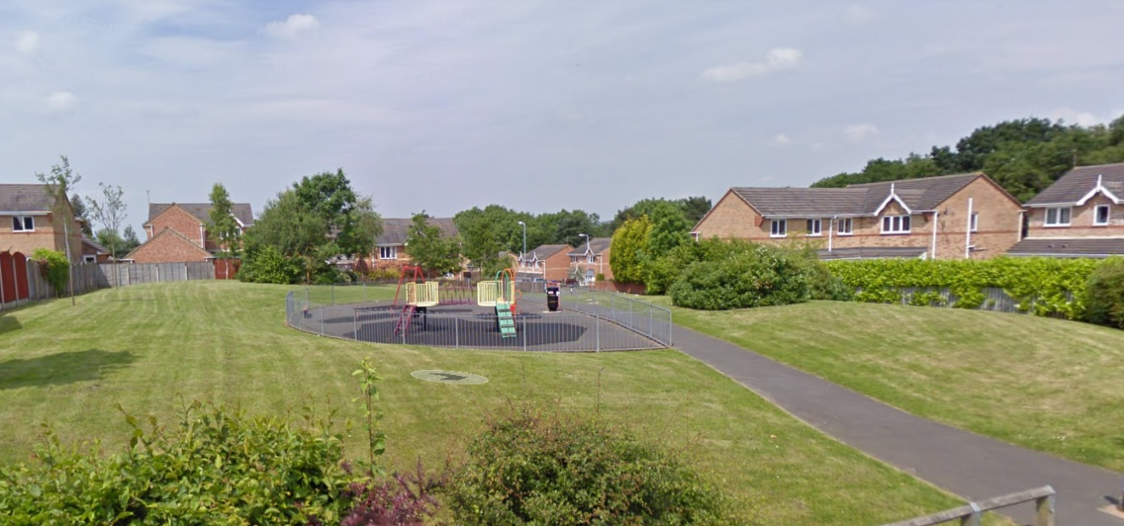

Map:

