43.
Site | Lawton Crescent, Lawton Street
Grid Reference / Post Code | SJ88688 57923
Brief Description | Pleasant green area with a few deciduous trees, which gives the properties in the crescent a green, open outlook.

Criteria.
Location  In reasonably close proximity to the community it serves | √ | Accessible to entire community with evidence of good informal uses, including children playing and dog walking.
Local Significance  Demonstrably special to a local community and holds a particular local significance, for example because of its beauty, historic significance, recreational value (including as a playing field), tranquility or richness of its wildlife. | √ | The area forms a pleasant, natural outlook for the residents of the crescent and transition space in a busy settlement area.
Size, Scale  Local in character and is not an extensive tract of land. | √
Recommendation |  | Suitable for Local Green Space Designation

Pictures:
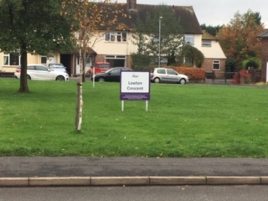
Map:

