**41**

|  |  |
| --- | --- |
| Site | **VOS 19- Braddocks Hay Recreation Ground, Church Road Playing Fields** |
| Grid Reference / Post Code | SJ886, 569 |
| Brief Description | Open grassland with play and sports facilities; and community garden and school to north. |

|  |  |  |
| --- | --- | --- |
| Criteria. |  |  |
| Location *In reasonably close proximity to the community it serves* | **√** |  |
| Local Significance *Demonstrably special to a local community and holds a particular local significance, for example because of its beauty, historic significance, recreational value (including as a playing field), tranquility or richness of its wildlife.* | **√** | Grassland provides recreational value and has full public access. Also open and allows broad, long distances views. Community garden has local significance. |
| Size, Scale *Local in character and is not an extensive tract of land*. | **√** |  |
| Recommendation |  | Existing Local Green Space Designation within the Local Plan |

Pictures:



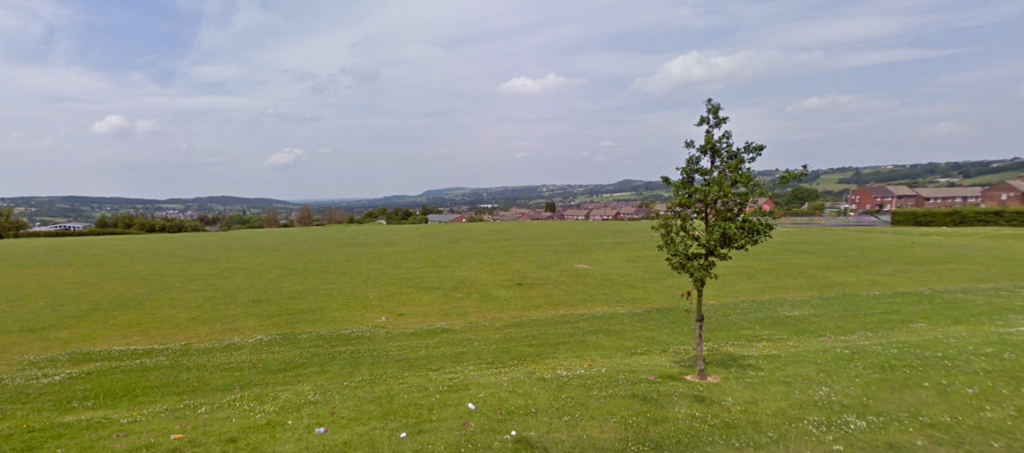

Map:

