4.
Site | Greenway Moor Gateway to the Town
Grid Reference / Post Code | SJ889, 590
Brief Description | The grass verge is on Congleton Road, just in front of Biddulph Bowling Green and extends along to the junction with Woodhouse Lane. Greenway Moor WI representatives perform this voluntary work regardless of whether the town is putting an entry into the competition or not. Therefore, it is an endeavour done by the people of the town, for the people of the town. This is a particularly good example (by the WI) and provides a beautiful passageway into the town from the north.

Criteria.
Location  In reasonably close proximity to the community it serves | √ | It is a grass verge by the main road side (A527) with seating. People walk passed it as they go to the bus stop, St Lawrence’s Church, the Bowling Club and Woodhouse School (to identify just a few). It provides a pleasant entrance to the town from the north.
Local Significance  Demonstrably special to a local community and holds a particular local significance, for example because of its beauty, historic significance, recreational value (including as a playing field), tranquility or richness of its wildlife. | √ | This work has been being carried out on a voluntary basis by the people of the town for more than 20 years. It is hugely valued by the people of the town and its visitors. This work is carried out throughout the year and this grass verge in particular is very well maintained. On entering the town this planted verge reinforces Biddulph’s reputation as the “Garden Town of Staffordshire”. Throughout the spring, summer and autumn months pollinators are supported by this planting and we should ensure it is not lost to them or to the people of Biddulph.
Size, Scale  Local in character and is not an extensive tract of land. | √ | This is not an extensive tract of land being only approximately 100 yds long. It has importance to the locality in that it reminds Biddulph and its visitors that the town is home to the best example of the Victorian Garden in the country (according to Alan Titchmarsh!)
Recommendation | √ | Suitable for Local Green Space Designation

Picture:

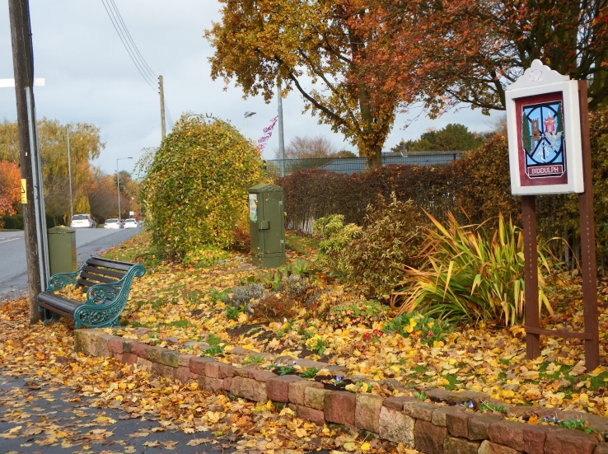

Map:

