**36.**

|  |  |
| --- | --- |
| Site | **Moorland Road allotments** |
| Grid Reference / Post Code | 53°07'10.9"N 2°10'10.5"W  ST8 6EN |
| Brief Description | Managed by Biddulph Town Council, providing an opportunity for residents of the town to grow their own food. |

|  |  |  |
| --- | --- | --- |
| Criteria. |  |  |
| Location *In reasonably close proximity to the community it serves* | **√** | Accessible to Biddulph residents via a waiting list. Site always full, with extensive waiting list. |
| Local Significance *Demonstrably special to a local community and holds a particular local significance, for example because of its beauty, historic significance, recreational value (including as a playing field), tranquility or richness of its wildlife.* | **√** | Particular local significance because of its recreational value; good level of wildlife observed.  Provides accessible facilities to enable local food production and improvements to health and wellbeing.  Improved community cohesion and sense of belonging. |
| Size, Scale *Local in character and is not an extensive tract of land*. | **√** |  |
| Recommendation |  | Suitable for Local Green Space Designation |

Pictures:

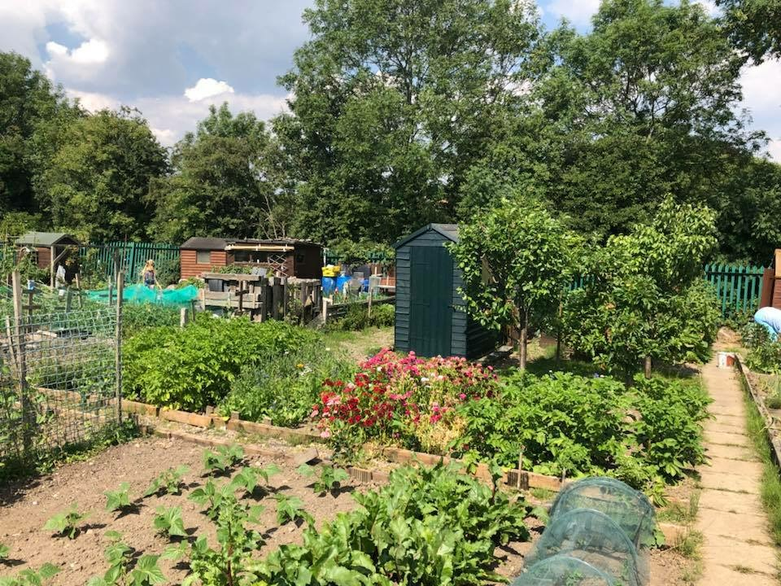

Map:

