**26.**

|  |  |
| --- | --- |
| Site | **Knypersley Bowling Club** |
| Grid Reference / Post Code | 53°06'18.3"N 2°10'48.5"W  ST8 7AE |
| Brief Description | Long established bowling club with thriving membership. Competes in local leagues and competitions |

|  |  |  |
| --- | --- | --- |
| Criteria. |  |  |
| Location *In reasonably close proximity to the community it serves* | **√** | Accessible to entire community, being situated along the A527. |
| Local Significance *Demonstrably special to a local community and holds a particular local significance, for example because of its beauty, historic significance, recreational value (including as a playing field), tranquility or richness of its wildlife.* | **√** | Recreational value. The club aims to promote the game of Crown Green Bowling, improving physical and mental health, and increased social activity.  Good facilities and evidence of frequent and regular use. |
| Size, Scale *Local in character and is not an extensive tract of land*. | **√** |  |
| Recommendation |  | Suitable for Local Green Space Designation |

Pictures:

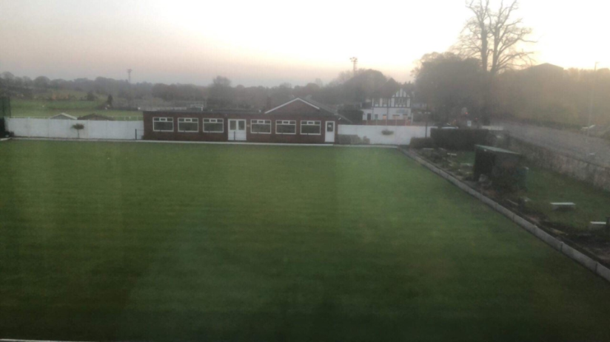

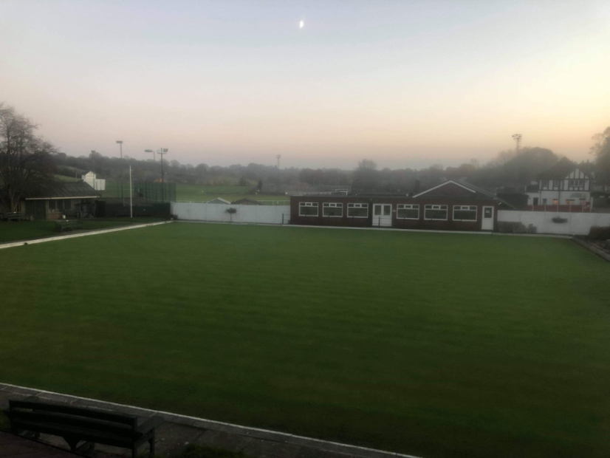

Map:

