|  |  |
| --- | --- |
| Site | **Knypersley Sports Ground** |
| Grid Reference / Post Code | 53°06'15.1"N 2°10'45.2"W  ST8 7AQ |
| Brief Description | Floodlit 5 a-side pitch and full-sized football pitch |

|  |  |  |
| --- | --- | --- |
| Criteria. |  |  |
| Location *In reasonably close proximity to the community it serves* | **√** | Accessible to entire community, being situated along the A527. |
| Local Significance *Demonstrably special to a local community and holds a particular local significance, for example because of its beauty, historic significance, recreational value (including as a playing field), tranquility or richness of its wildlife.* | **√** | Recreational value. Good public access for formal and informal uses.  Provides opportunities for increased physical activity, improving mental and physical health.  Encourages improvements in community cohesion and children’s learning. |
| Size, Scale *Local in character and is not an extensive tract of land*. | **√** |  |
| Recommendation |  | Suitable for Local Green Space Designation |

Picture:

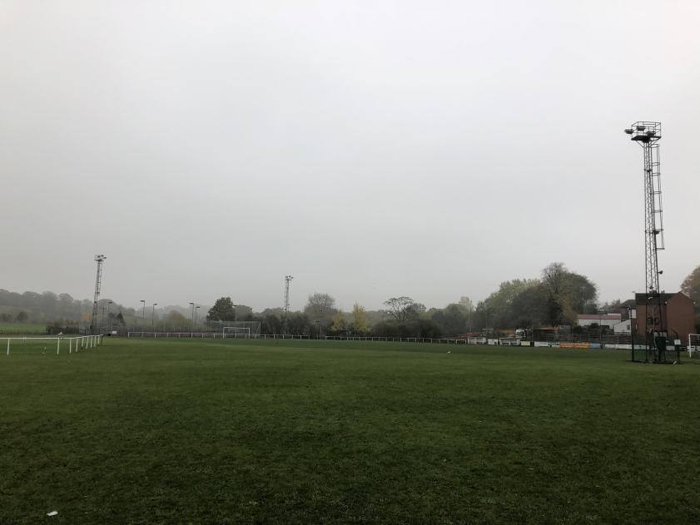Map:

