|  |  |
| --- | --- |
| Site | **Corner of The Uplands** |
| Grid Reference / Post Code | 53°07'27.4"N 2°09'52.5"W  ST8 7ER |
| Brief Description | Grassed area, providing attractive and important green buffer between housing developments. |

|  |  |  |
| --- | --- | --- |
| Criteria. |  |  |
| Location *In reasonably close proximity to the community it serves* | **√** | Accessible to entire community with evidence of good informal uses, including children playing and dog walking. |
| Local Significance *Demonstrably special to a local community and holds a particular local significance, for example because of its beauty, historic significance, recreational value (including as a playing field), tranquility or richness of its wildlife.* | **√** | Enhances the attractiveness of the estate in which it sits, providing a good contribution to the setting of the local area.  Helps to contribute towards making Biddulph a more attractive place to live, work and visit. |
| Size, Scale *Local in character and is not an extensive tract of land*. | **√** |  |
| Recommendation |  | Suitable for Local Green Space Designation |

Pictures:

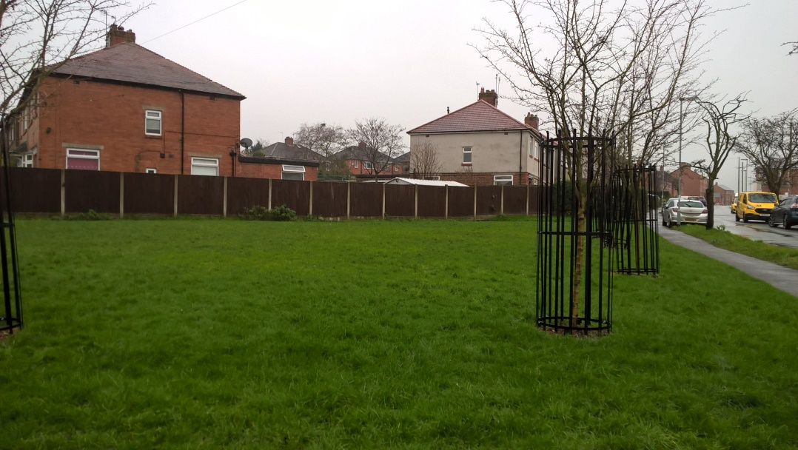

Map:

