Site | Eiger Close grassed area (Uplands Estate)
Grid Reference / Post Code | 53°07'22.9"N 2°09'41.4"W  ST8 7DX
Brief Description | Grassed area on the periphery of the housing estate, providing attractive entrance and important green buffer between housing developments.

Criteria.
Location  In reasonably close proximity to the community it serves | √ | Accessible to entire community.
Local Significance  Demonstrably special to a local community and holds a particular local significance, for example because of its beauty, historic significance, recreational value (including as a playing field), tranquility or richness of its wildlife. | √ | Recreational value. Provides visual break and transition space in a busy settlement area.  Good visual attractiveness contributing to the setting of the local area, providing important buffer. Helps to contribute towards making Biddulph a more attractive place to live, work and visit.
Size, Scale  Local in character and is not an extensive tract of land. | √
Recommendation |  | Suitable for Local Green Space Designation

Pictures:

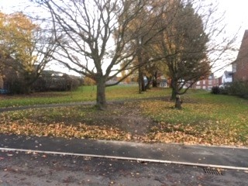

Map:

