Site | Biddulph Valley Way  (northern part of, known as Whitemoor Local Nature Reserve)
Grid Reference / Post Code | SJ885605
Brief Description | This site is a local nature reserve with great accessability due to the Biddulph Valley Way running through it. Opportunities for interpretation about the local wildlife are provided with numerous signs.

Criteria.
Location  In reasonably close proximity to the community it serves | √ | The Biddulph Valley Way is a popular 4.5 mile walking route, being relatively flat, traffic-free and suitable for walkers, cyclists and horse riders. Local visitors to this site include residents from both Cheshire (Congleton) and Staffordshire (Biddulph). The linear route also attracts those from further afield, being part of the National Cycle Network (NCN Route 55) which links Stoke-on-Trent to the south, via Biddulph to Congleton in the north. The route through the Biddulph Valley is especially picturesque in places, with numerous viewpoints providing lovely views out into the countryside beyond.
Local Significance  Demonstrably special to a local community and holds a particular local significance, for example because of its beauty, historic significance, recreational value (including as a playing field), tranquility or richness of its wildlife. | √ | History: Originally a branch of the North Staffordshire Railway (or ‘Knotty’) The Biddulph Valley Way is an important historic linear feature which runs to the West of the town. Trains carrying coal, and later passengers, from the Potteries to Congleton ran along the line between1859-1968. Following the demise of this local industry, the line was turned into a multiuse path for the enjoyment of local people.  Biodiversity: the path has a mixture of embankments, cuttings, small copses, hedgerows and ditches. The Whitemore Local Nature Reserve is a 4.3ha site at the northern end of Biddulph Valley Way and is a Staffordshire Site of Biological Importance due to its woodland wildlife. This includes the English bluebell, wood anemone, wood sorrel and yellow archangel. A Key Stage 2 Education pack for schools about Whitemore Local Nature Reserve has been created by Staffordshire Moorlands District Council.  Links to the wider countryside: the Biddulph Valley Way is linked to numerous footpaths, including the Gritstone Trail, a challenging 35-mile long distance footpath from Disley to Kidsgrove.
Size, Scale  Local in character and is not an extensive tract of land. | √ | The Whitemore Local Nature Reserve is a 4.3ha site.
Recommendation |  | Suitable for Local Green Space Designation

Pictures:

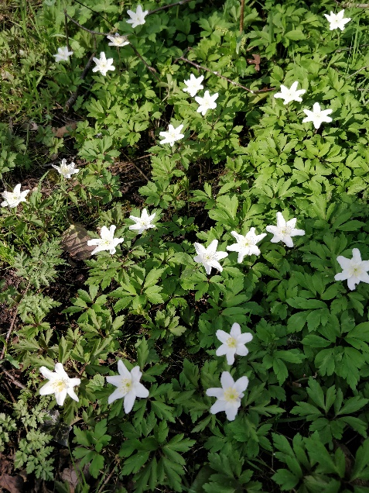  Wood Anenome along the Biddulph Valley Way | 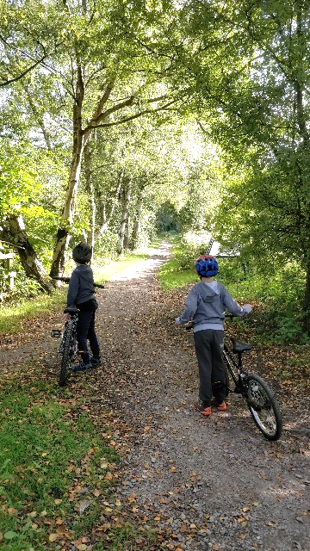  Route 55 running through Whitemoor Local Nature Reserve.
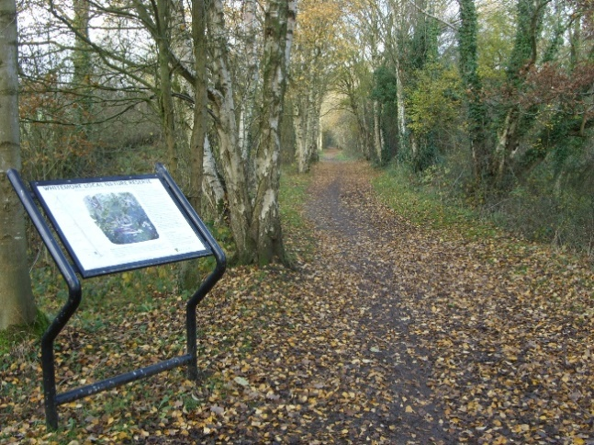 | 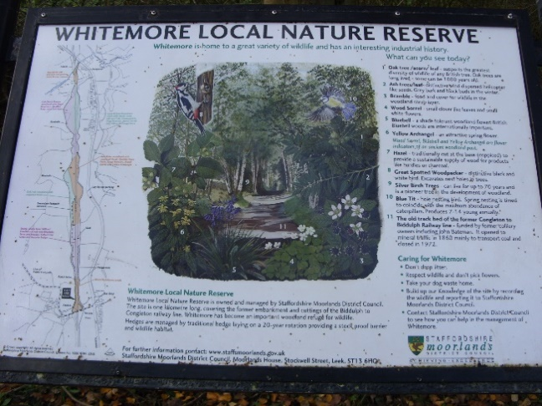  Interpretation at Whitemore Local Nature Reserve.

Map:

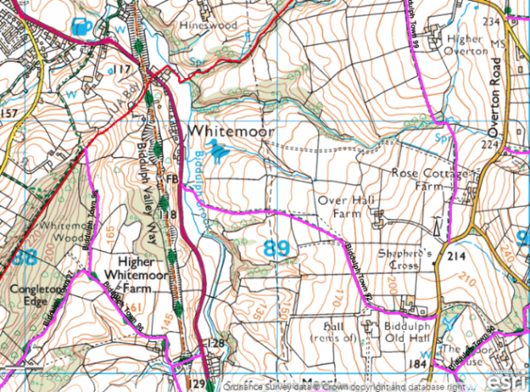 | 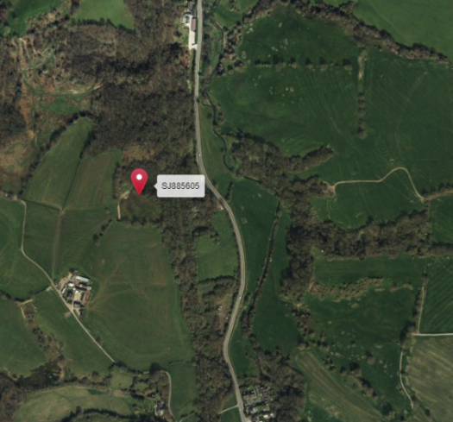
Page 2 Biddulph Valley Way

