# 14

|  |  |
| --- | --- |
| Site | **Ringwork Castle, Bailey's Wood**  Historic site of Biddulph Castle – a Scheduled Ancient Monument (earthworks) |
| Grid Reference / Post Code | SJ 88934 59478 |
| Brief Description | Small wooded area, the site of an old Ringwork castle. PRN Number 00179. This is a cultural and ecologically important site with easy access via the footpath network for local residents and visitors along the Biddulph Valley Way. It is an ancient and semi-natural woodland-more than 400 years old. |

|  |  |  |
| --- | --- | --- |
| Criteria. |  |  |
| Location *In reasonably close proximity to the community it serves* | √ | On the A523, just south of the junction with Fold Lane on the opposite side of the road. |
| Local Significance *Demonstrably special to a local community and holds a particular local significance, for example because of its beauty, historic significance, recreational value (including as a playing field), tranquility or richness of its wildlife.* | √ | **Biodiversity** – broadleaved woodland with a beautiful carpet of English Bluebells in the Spring. The range of important and varied habitats including the open area, wet hollow and bank side vegetation which are managed by the Woodland trust to maintain the existing floral diversity as well as an important habitat for insects. The ride edges will also be managed to provide greater potential as a wildlife corridor, especially for otter and Pipistrelle bats.  **History:** Biddulph castle is situated in Baileys Wood overlooking Biddulph Brook. It was of motte and bailey construction and the earthwork remains are a scheduled ancient monument which was excavated in 1967 when 12th century artefacts were discovered. It was the home of the Biddulph family until they moved to their new house (Biddulph Hall), just north-west of this site, in the 16th century (PRN Number 00179) |
| Size, Scale *Local in character and is not an extensive tract of land*. | **√** | 6.65 acres of undulating, often steep woodland falling to Biddulph Brook below (Woodland Trust site).  2.6ha of ancient and semi-ancient woodland |
| Recommendation | **√** | Suitable for Local Green Space Designation |



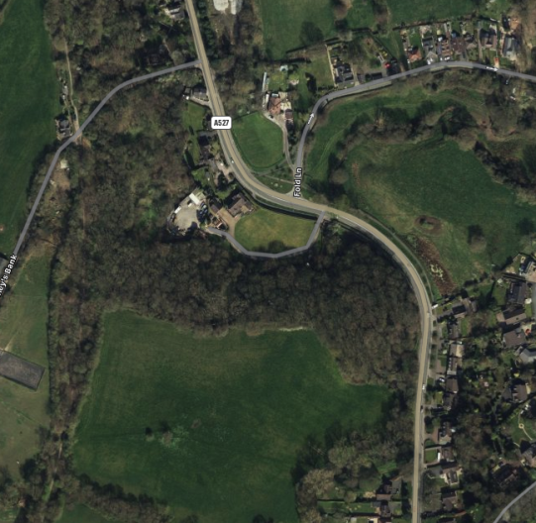

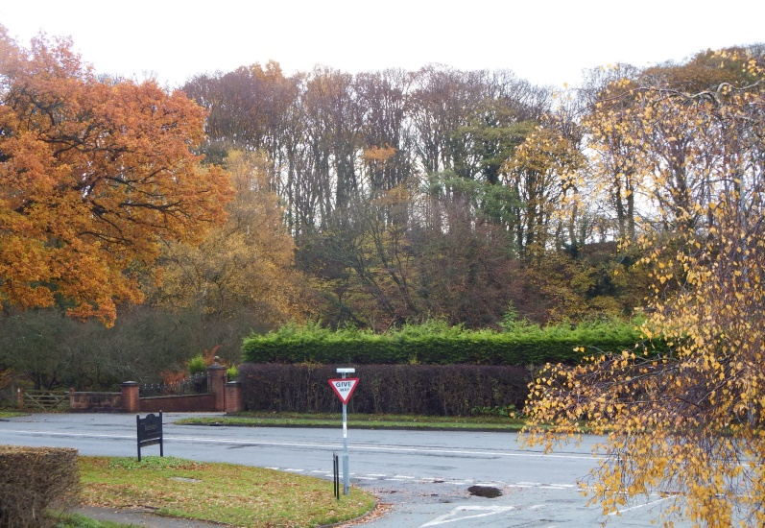

From Fold Lane

Pictures:

|  |  |
| --- | --- |
| Pictures inside Bailey’s Wood and viewed from the main road A527. |  |
|  |  |
|  |  |

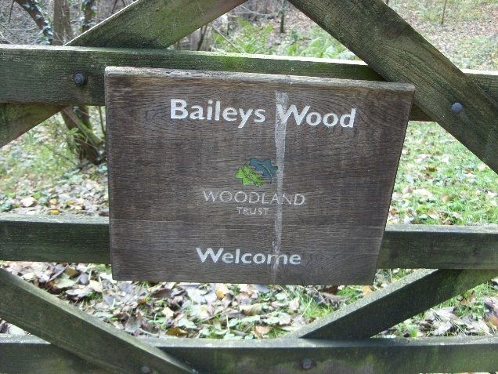

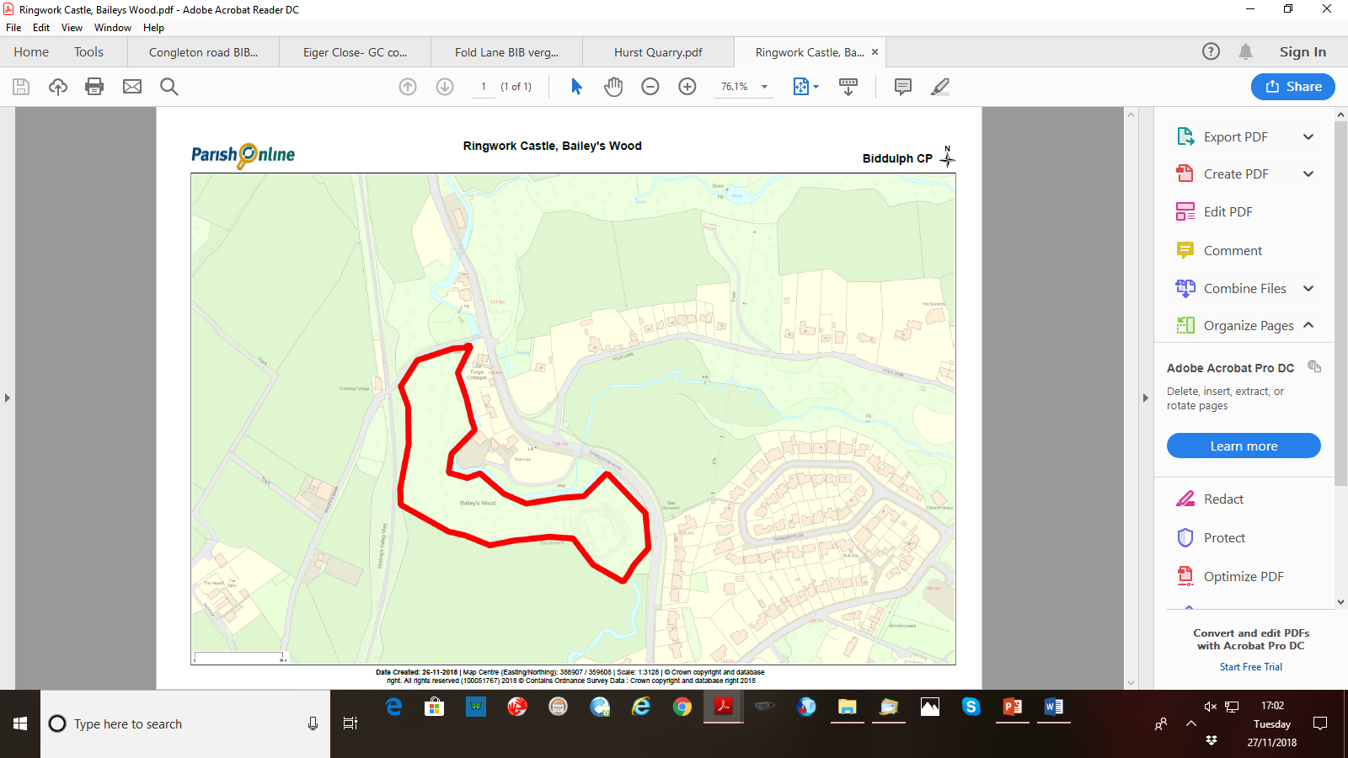

Maps:

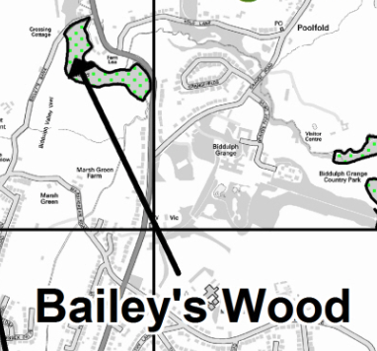

**Page 2 Ringwork Castle**