|  |  |
| --- | --- |
| Site | **Fields Behind Talbot car park** |
| Grid Reference / Post Code | 53°08'06.8"N 2°09'27.5"W |
| Brief Description | Open space with hens roaming free, the historic leat runs along the periphery of the site. |

|  |  |  |
| --- | --- | --- |
| Criteria. |  |  |
| Location *In reasonably close proximity to the community it serves* | **√** | Access via public footpath, which goes around the perimeter. |
| Local Significance *Demonstrably special to a local community and holds a particular local significance, for example because of its beauty, historic significance, recreational value (including as a playing field), tranquility or richness of its wildlife.* | **√** | The site has particular local significance because of its historic significance, in that it is the setting of the leat, which begins within the Biddulph Grange Country Park.  Evidence of wildlife on the site and good visual attractiveness. |
| Size, Scale *Local in character and is not an extensive tract of land*. | **√** | Typical field size. |
| Recommendation |  | Suitable for Local Green Space Designation |

Pictures:

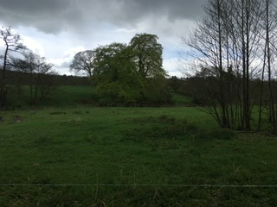

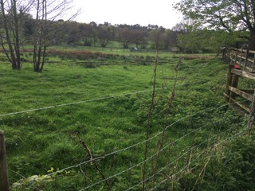

Map:

