7.
Site | Well Street, Biddulph in Bloom Allotment
Grid Reference / Post Code | 53°06'52.4"N 2°10'19.9"W  ST8 6HY
Brief Description | Without this facility the work done by Biddulph in Bloom volunteers could not be carried out. Much of what we see on the various plots is grown on this site from seed; the huge preparation work that most of us don’t see.

Criteria.
Location  In reasonably close proximity to the community it serves | √ | It is within the confines of the town boundary and volunteers have no difficulty in accessing. During the prolonged weeks of drought during the summer of 2018, the planting was kept watered by the volunteers by using water from a nearby stream. This task was only possible because of the site’s proximity to the stream, within the bounds of the community it serves.
Local Significance  Demonstrably special to a local community and holds a particular local significance, for example because of its beauty, historic significance, recreational value (including as a playing field), tranquility or richness of its wildlife. | √ | This site is “silently” special to the community since, without it, the work done by the town’s volunteer base could not be carried out. If this site were not protected the gardened sites all around the town would be bare and very drab. The whole character of the town would be changed for the worst.
Size, Scale  Local in character and is not an extensive tract of land. | √ | It is local in character since it serves the gardening heritage provided by Biddulph Grange Gardens. It is not an extensive tract of land being about the size of a typical allotment.
Recommendation | √ | Suitable for Local Green Space Designation

Pictures:

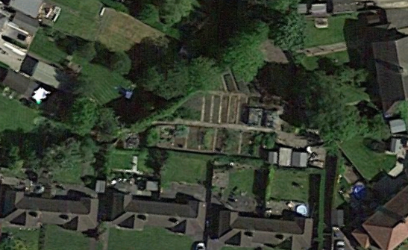
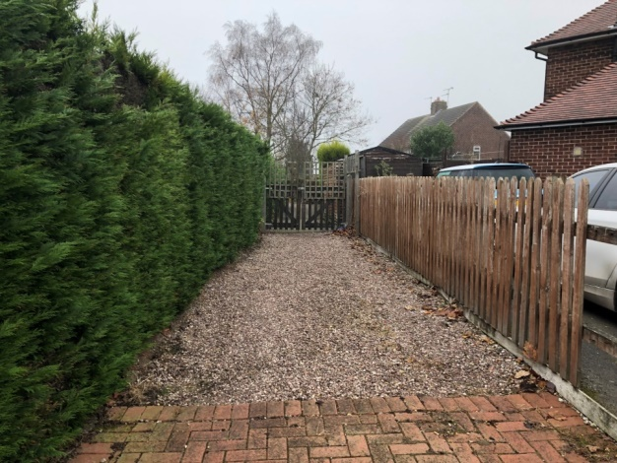

Map:

