68.
Site | Land adjacent New Rd Methodist Church
Grid Reference / Post Code | 53°07'20.2"N 2°08'19.5"W
Brief Description | Green space between bungalow and church

Criteria.
Location  In reasonably close proximity to the community it serves | √ | Adjacent to New Rd Church
Local Significance  Demonstrably special to a local community and holds a particular local significance, for example because of its beauty, historic significance, recreational value (including as a playing field), tranquility or richness of its wildlife. | √ | Green space opposite school lane, used to display school well dressing tableaus.
Size, Scale  Local in character and is not an extensive tract of land. | √
Recommendation |  | Suitable for Local Green Space Designation

Pictures:

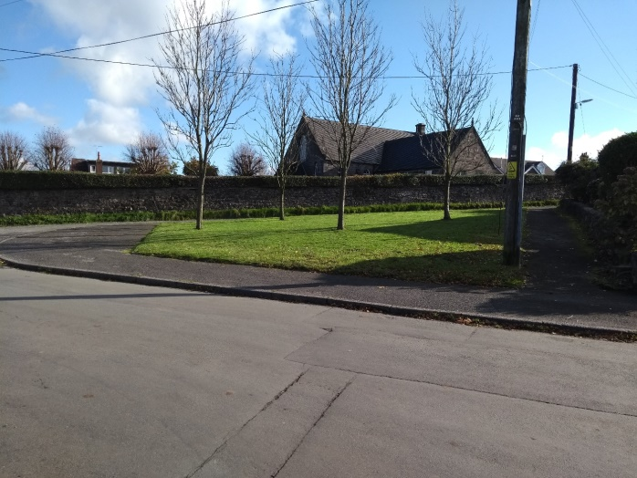
Map:

