66.
Site | Hot Scotch Park
Grid Reference / Post Code | ST8 7HP
Brief Description | Newly refurbished children’s playground and adjoining grass play area

Criteria.
Location  In reasonably close proximity to the community it serves | √ | The playground is about 150 mtrs from the centre of the village next to the Village hall.
Local Significance  Demonstrably special to a local community and holds a particular local significance, for example because of its beauty, historic significance, recreational value (including as a playing field), tranquility or richness of its wildlife. | √ | This is the only playground in the village and has recently been refurbished after a local campaign to raise funds. It has special significance to the community since the money was raised by local people and it was not paid for by the council. The playground has been there for over 40 years and is the only play area in the village. The adjoining grass area was previously used as a local football pitch and is currently not used as such because of the lack of changing facilities. It is used by local children as a play area for ball games and other general play.
Size, Scale  Local in character and is not an extensive tract of land. | √ | Playground is approx. 25mtrs by 50mtrs and the field the size of a football pitch.
Recommendation |  | Suitable for Local Green Space Designation

Pictures:

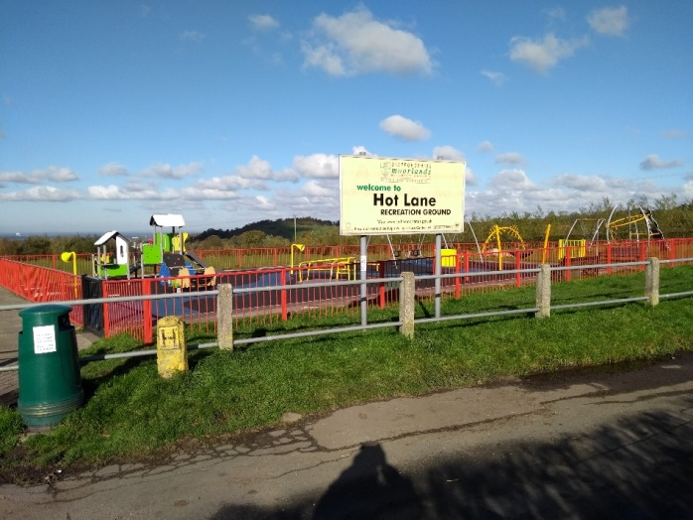 | 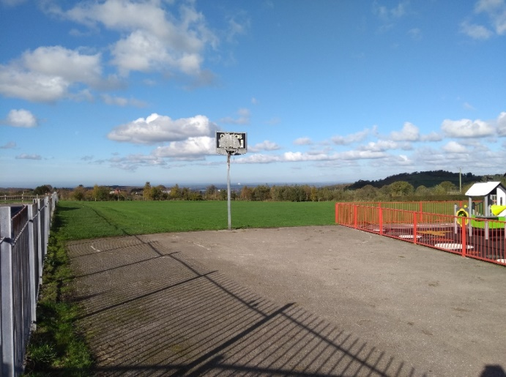
Map:

