**61.**

|  |  |
| --- | --- |
| Site | **The Paddock Play Area** |
| Grid Reference / Post Code | 53°07'01.1"N 2°10'44.0"W  ST8 6SY |
| Brief Description | Owned and maintained by Staffordshire Moorlands District Council. In need of modernisation, but an important transition area between settlements. |

|  |  |  |
| --- | --- | --- |
| Criteria. |  |  |
| Location *In reasonably close proximity to the community it serves* | **√** | Accessible to entire community with potential for enhanced informal uses. |
| Local Significance *Demonstrably special to a local community and holds a particular local significance, for example because of its beauty, historic significance, recreational value (including as a playing field), tranquility or richness of its wildlife.* | **√** | Recreational value.  Enhances the attractiveness of the estate in which it sits, providing a good contribution to the setting of the local area.  Provides an outlook for surrounding residential properties. |
| Size, Scale *Local in character and is not an extensive tract of land*. | **√** |  |
| Recommendation |  | Suitable for Local Green Space Designation |

Pictures:

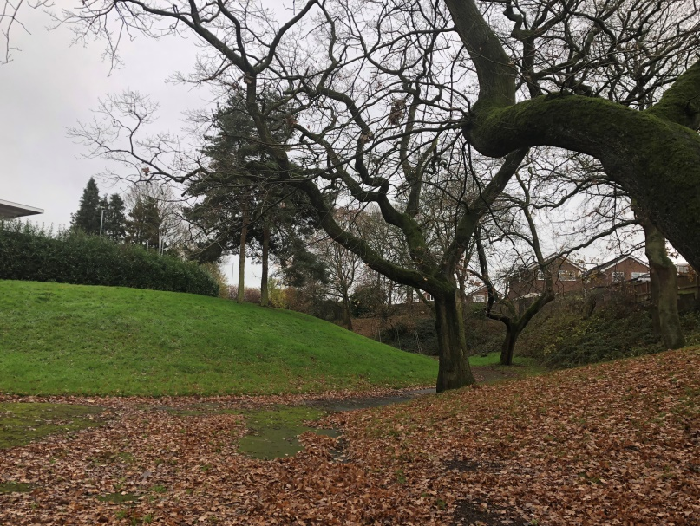

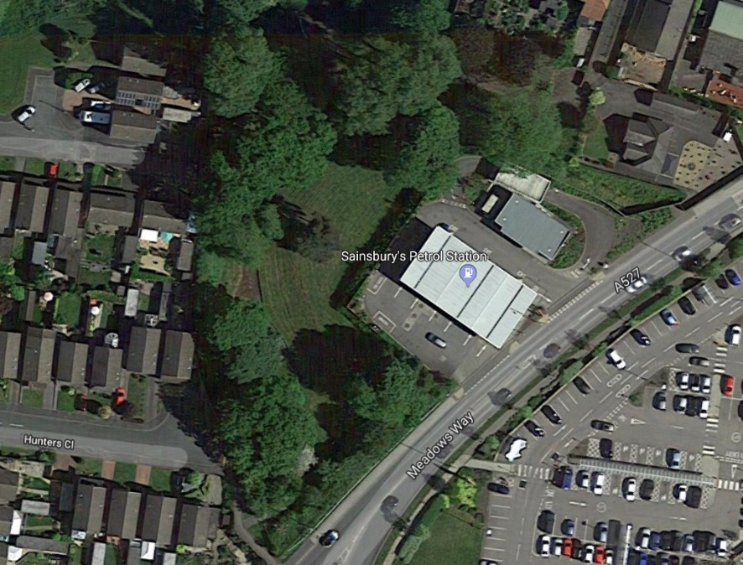

Map:

