53.
Site | VOS 11- ‘Gillow Heath Recreation Ground’  Also known as Halls Road Sports Ground / Playing Fields and ‘the Sandhole’
Grid Reference / Post Code | SJ 88422 58504
Brief Description | This site is well used by numerous local residents and different sports groups across the town (ie. football clubs). The various facilities mean that people of all ages are catered for, with a good circular footpath providing easy access around the site and onto the wider footpath network beyond.

Criteria.
Location  In reasonably close proximity to the community it serves | √ | Easily accessible by the local community and surrounded by housing. Well used in both Summer and Winter months.
Local Significance  Demonstrably special to a local community and holds a particular local significance, for example because of its beauty, historic significance, recreational value (including as a playing field), tranquility or richness of its wildlife. | √ | Community use: A well-used site with various sporting facilities including football pitches, tennis courts, outdoor gym equipment and walking routes. Well used by local residents, dog walkers and sports enthusiasts.  Biodiversity: Small areas of taller vegetation provide some habitat for wildlife but this could be encouraged in places. The site shares its eastern border with the Biddulph Valley Way and the woodland edge running along this.
Size, Scale  Local in character and is not an extensive tract of land. | √ | c. 5ha
Recommendation | √ | Existing Local Green Space Designation within the Local Plan

Pictures:

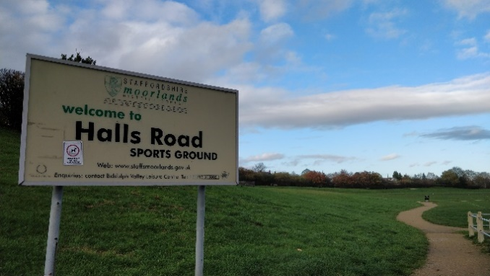 | 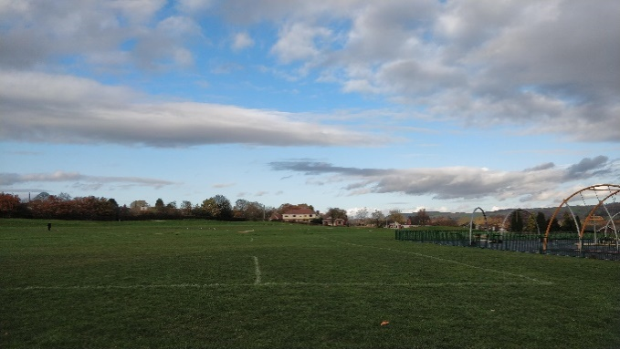
 | 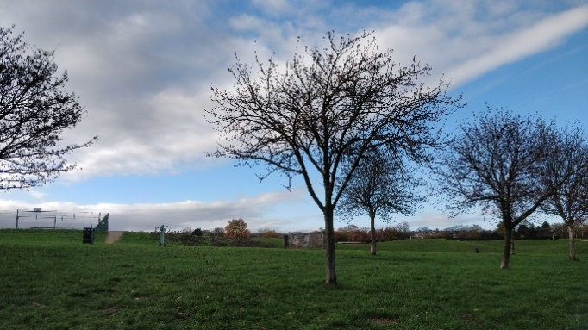
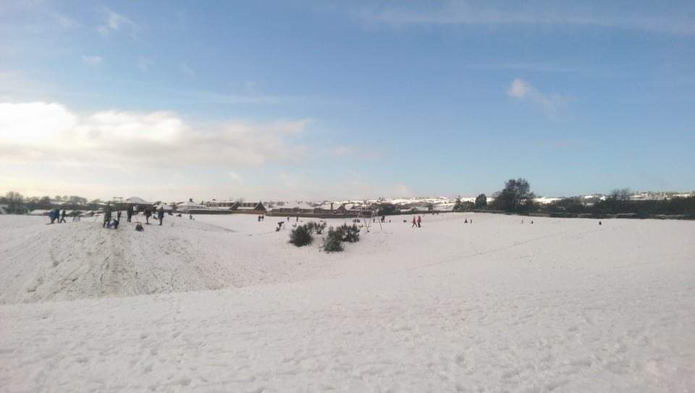 | 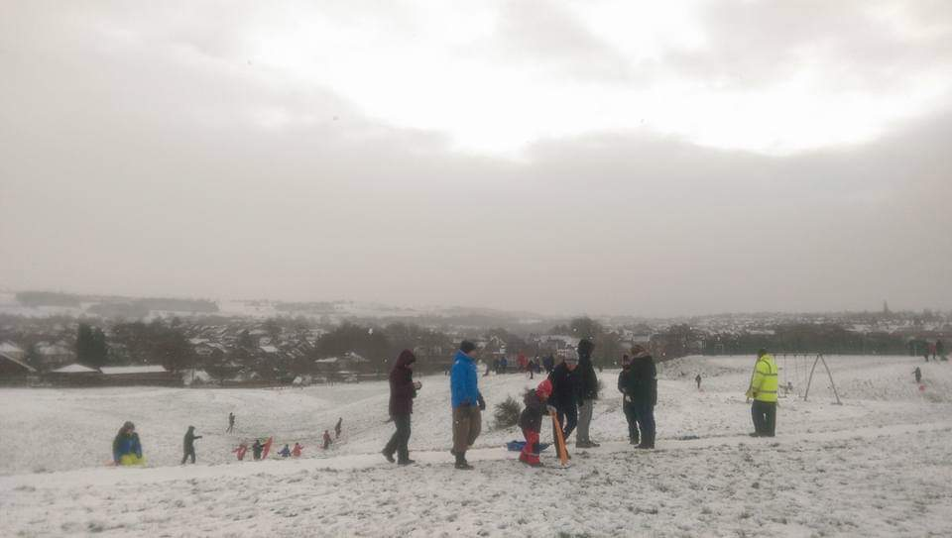

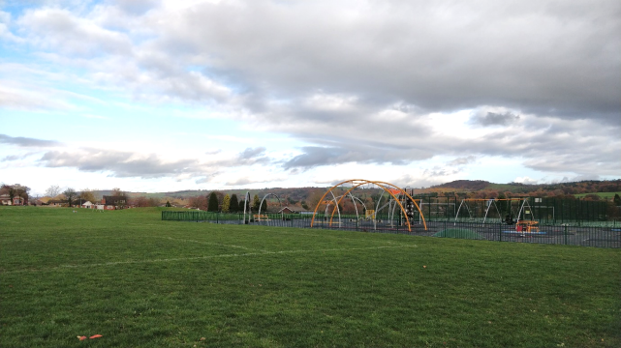

Maps:
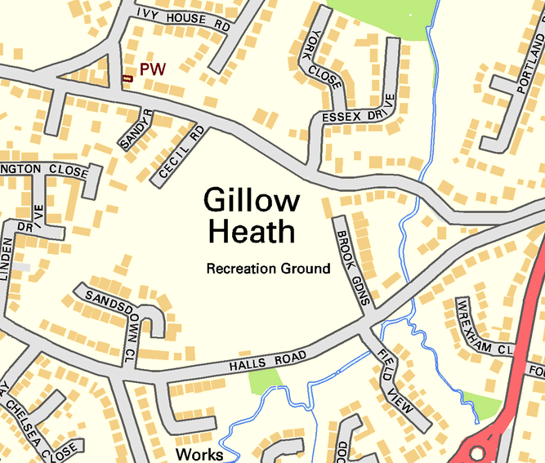 | 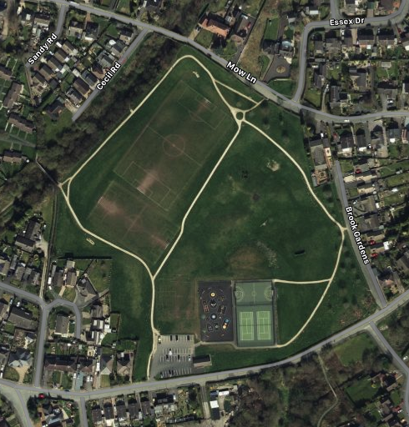

Page 2 Gillow Heath Recreation Ground

