# 47.

|  |  |
| --- | --- |
| Site | **Church Road roundabout** |
| Grid Reference / Post Code | 53°06'45.6"N 2°10'11.8"W  ST8 6JL |
| Brief Description | Accessible open space providing an important transition area between settlements. |

|  |  |  |
| --- | --- | --- |
| Criteria. |  |  |
| Location *In reasonably close proximity to the community it serves* | **√** | Accessible to entire community with evidence of good informal uses, including children playing and dog walking. |
| Local Significance *Demonstrably special to a local community and holds a particular local significance, for example because of its beauty, historic significance, recreational value (including as a playing field), tranquility or richness of its wildlife.* | **√** | Enhances the attractiveness of the estate in which it sits, providing a good contribution to the setting of the local area.  Display of large-scale artwork, which can be viewed from all side.  Provides an outlook for surrounding residential properties. |
| Size, Scale *Local in character and is not an extensive tract of land*. | **√** | Not an extensive tract of land; an important green area on a densely populated housing estate. |
| Recommendation |  | Suitable for Local Green Space Designation |

Picture:

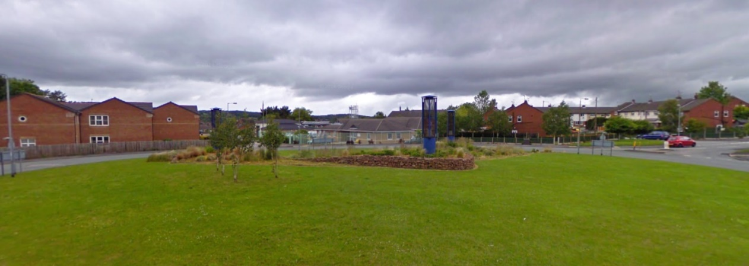

Map:

