**37.**

|  |  |
| --- | --- |
| Site | **VOS 20, section B ‘Springfield Road, Lower Level’- Behind St David’s Way** |
| Grid Reference / Post Code | 53°06'26.2"N 2°09'51.0"W  ST8 7XA |
| Brief Description | Accessible open space providing an important area for the community to engage in recreational activities; an important transition area between settlements. Includes wooden play/ gym equipment. |

|  |  |  |
| --- | --- | --- |
| Criteria. |  |  |
| Location *In reasonably close proximity to the community it serves* | **√** | Housing on two sides of this triangular site, with allotments to the third site. Informal use for dog walking and as a play area for young people. |
| Local Significance *Demonstrably special to a local community and holds a particular local significance, for example because of its beauty, historic significance, recreational value (including as a playing field), tranquility or richness of its wildlife.* | **√** | Recreational value and adds to the local amenity, providing opportunities to improve physical and mental health through exercise.  Improves community cohesion and provides an opportunity for wildlife habitats. |
| Size, Scale *Local in character and is not an extensive tract of land*. | **√** |  |
| Recommendation |  | Existing Local Green Space Designation within the Local Plan |

Pictures:

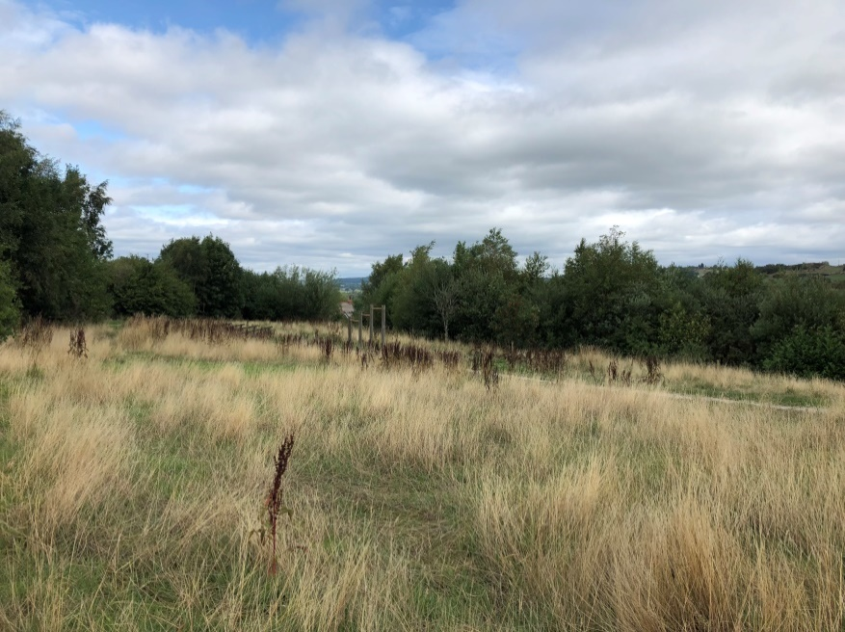

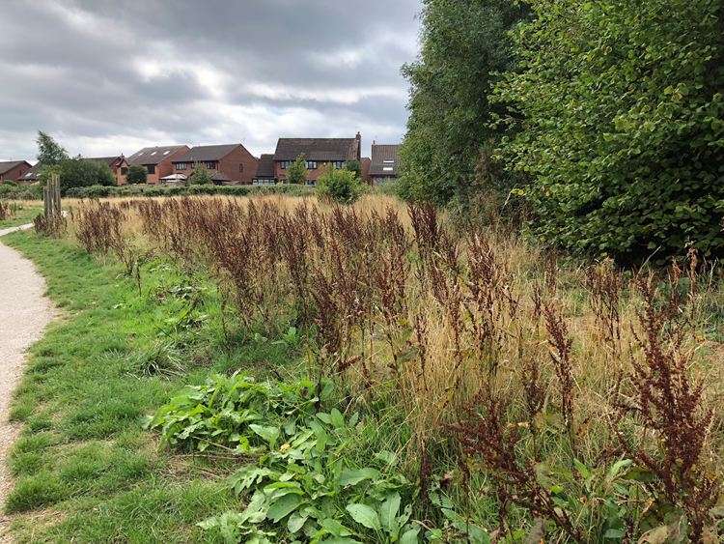

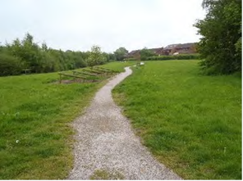

Map:

