**32.**

|  |  |
| --- | --- |
| Site | **Parts of Greenway Bank Country Park (4 sites)**   1. **Greenway Bank Country Park** 2. **Greenway Wood & Knypersley Wood (SJ8897755495; SJ8915155495)** 3. **Crowborough Wood (SJ903561)** 4. **Knypersley Reservoir Sandstones (SJ894555)** |
| Grid Reference / Post Code | See above |
| Brief Description | The ancient and semi-natural woodlands contained within Greenway Bank Country Park are important habitats for numerous creatures. The sites, added together, form a vital reserve for wildlife and part of a wider area-wide wildlife corridor. Consists of open water, deep sandstone gorges, predominantly broad-leaved woodland with marshy grassland, swamp and acidic areas mainly in the north-east section. Water voles have been recorded on site in the past. There are some significant old trees on the ridge leading to Gawton's Stone. |

|  |  |  |
| --- | --- | --- |
| Criteria. |  |  |
| Location *In reasonably close proximity to the community it serves* | √ | The site is accessible to walkers and cyclists, being serviced by two car parks and a circular footpath. It is also linked to the wider footpath network providing easy foot access for residents living in Biddulph, Brown Edge and the north of Stoke-on-Trent. |
| Local Significance *Demonstrably special to a local community and holds a particular local significance, for example because of its beauty, historic significance, recreational value (including as a playing field), tranquility or richness of its wildlife.* | √ | **History:** The site was once part of the Knypersley Hall estate. The site was owned in 1778 by Hugh Henshall, brother-in-law of James Brindley, and the engineer in charge of completing the Trent and Mersey canal. He created two lakes at Greenway, the upper in 1781 being fed by the Trent via a leat from Knypersley. The larger lake, Knypersley Pool, was created in 1828 to feed the Caldon Canal via the Trent.  **Biodiversity:** Listed as a Local Wildlife Site / Site of Biological Importance for its’ diverse mix of habitats, ground flora and insects and recorded in the Ancient Woodland Inventory for its impressive woodland canopy.  **Geology:** The Knypersley Reservoir Sandstones are designated as a Regionally Important Geological Site as an example of sandstone from the lower Coal Measures. |
| Size, Scale *Local in character and is not an extensive tract of land*. | **√** | Although this is a large site (approx. 9 ha), much of it consists of open water and steep-sided woodland gorges.  Protecting the entire site, separated into smaller parcels, would ensure that the mix of habitats are not fragmented over time. See below for specific areas. |
| Recommendation |  | Suitable for Local Green Space Designation |

**Maps:**

Parts of Greenway Bank Country Park – Greenway Wood& Knypersley Wood, Greenway Bank, Crowborough Wood, UNK (unknown name) and the Knypersley Reservoir Sandstones:

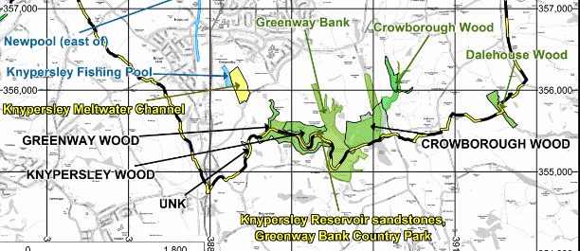

Greenway Wood & Knypersley Wood (SJ8897755495; SJ8915155495):

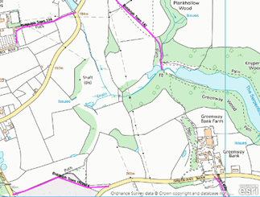



Greenway Bank Country Park:

|  |  |
| --- | --- |
|  |  |

Crowborough Wood (SJ903561):

|  |  |
| --- | --- |
|  |  |

**Page 2 Greenway Bank**

Knypersley Reservoir Sandstones (SJ894555):

|  |  |
| --- | --- |
|  |  |
|  | |

Pictures:

|  |  |
| --- | --- |
|  |  |

Proposed areas to be protected with Local Green Space Designation: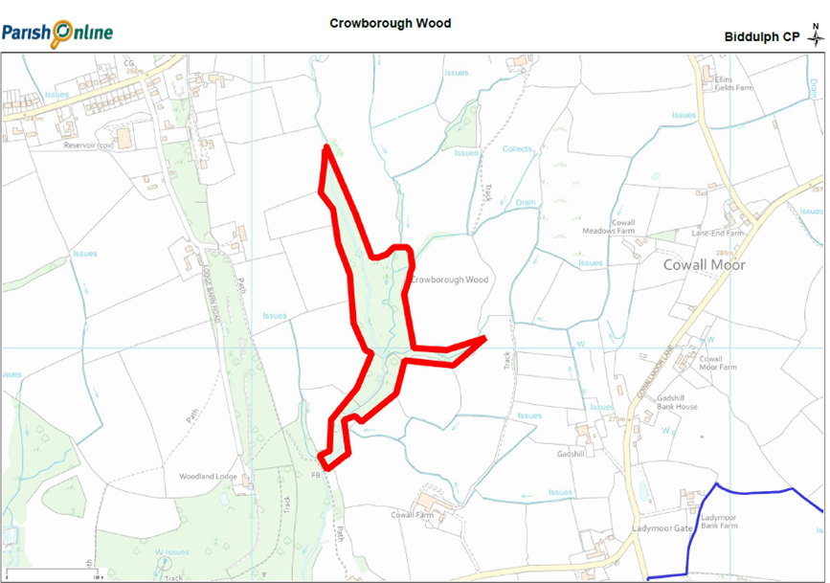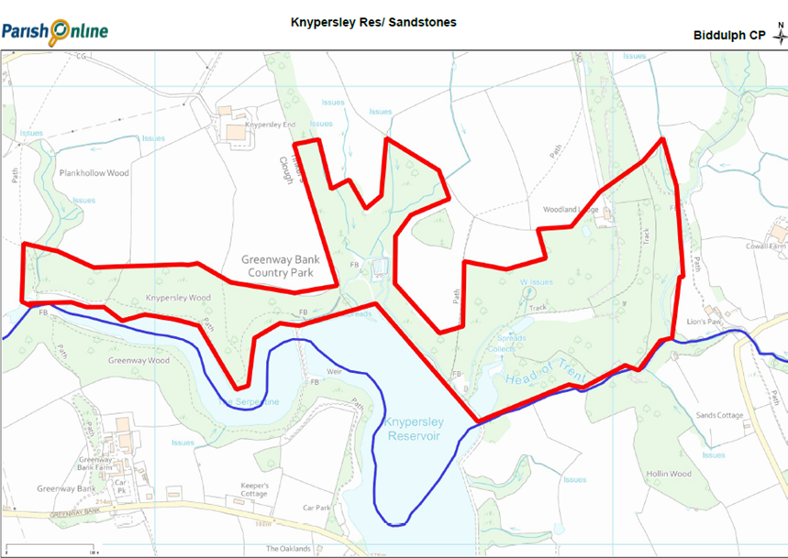 **Page 3 Greenway Bank**