31.
Site | Mill Hayes Grass Verges
Grid Reference / Post Code | SJ880 559
Brief Description | This has been planted with 8 trees and also has planted beds. This is a grassy area with seating.

Criteria.
Location  In reasonably close proximity to the community it serves | √ | On A527 located on the edge of town.
Local Significance  Demonstrably special to a local community and holds a particular local significance, for example because of its beauty, historic significance, recreational value (including as a playing field), tranquility or richness of its wildlife. | √ | This site provides an introduction to the Garden Town of Staffordshire on entering from the south by showing a tended area in the midst of the town’s industrial units to the west. The colour of the trees in autumn is particularly vibrant.
Size, Scale  Local in character and is not an extensive tract of land. | √ | Narrow sections; important boundary treatments.
Recommendation | √ | Suitable for Local Green Space Designation

Pictures:

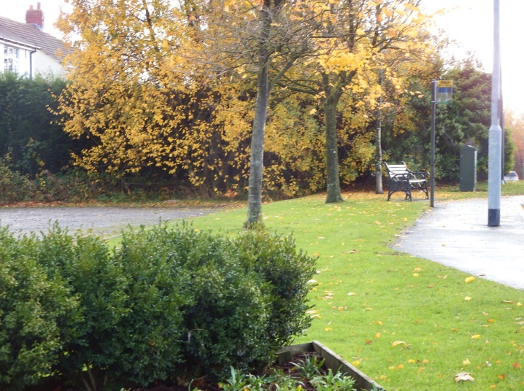 | 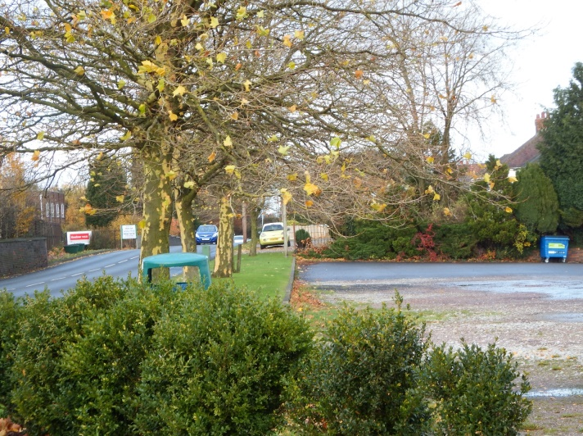
Map:

