2.
Site | The Clough
Grid Reference / Post Code | SJ896, 598; SJ891, 588 & SJ890, 597
Brief Description | This is a local beauty spot, used by residents for short family walks and walking dogs. Although this land having TPO’s placed on it, back in the 1970’s a large number were cut down and Japanese Knotweed took over. This has now been rectified by the current owners with the planting of over 300 native trees in 2001 (once the knotweed had been eradicated). It is vital that now this place has been reclaimed for nature, it is retained for responsible recreational use by the local community.

Criteria.
Location  In reasonably close proximity to the community it serves | √ | Within walking distance of the main road and accessed via Hurst Road (a public footpath which starts next to the Talbot pub). Many people park in the pub carpark, take a walk through the Clough and relax in the Talbot afterwards.
Local Significance  Demonstrably special to a local community and holds a particular local significance, for example because of its beauty, historic significance, recreational value (including as a playing field), tranquility or richness of its wildlife. | √ | The Clough is an old route from Biddulph Old Hall to Biddulph Grange and was used by the Batemans and Heaths in Victorian times and more recently. It is known that there was an old Batemen bridge (a very particular style) in the valley crossing the stream (although the exact position has not yet been determined). There is also an old bridge (PRN Number 53988 ) still in existence which the current footpath crosses. The footpath currently exits onto Fold Lane, however it used to continue under the road and on through land across the road to Biddulph Grange. This tunnel under Fold Lane, formed part of the private walk linking Bidduplh Old Hall to the Grange (PRN Number 53987). The tunnel was filled in during the early 2,000s when the roadway collapsed. This route is regularly used by walking groups as part of a longer hike, including Biddulph Ramblers.  The first part of the Clough (nearest to Grange Road was the site of Biddulph Mill, shown on William Yates's map of 1775, and identified on the first Edition Ordnance Survey map of 1888 as a corn mill. The mill is named as Biddulph Mill and identified as a corn mill on the 1st Edition Ordnance Survey map of 1888. The site of a mill is marked in this location on William Yates's map of 1775. It is believed that the corn mill pre-dated the building of Biddulph Old Hall in the 16th century. The mill was still grinding corn using water power in 1912, but it had probably ceased to do so by 1920. The derelict mill was demolished in the late 1940s.
Size, Scale  Local in character and is not an extensive tract of land. | √ | It is locally known as The Clough and contains the remains of 2 man-made dam constructions which were connected with the powering of mill workings. There are still outcrops of coal on the banks which were locally collected for domestic use. Despite these the valley provides an ideal habitat for flora and fauna - in springtime the ground is covered in bluebells, daffodils, red campion, wood sorrel and wood anemone. It is also inhabited with rabbits, foxes, various owls, dippers, buzzards, most tits and finches, and bats. In addition there are some interesting tree species, planted by the Batemans including Scotts Pine, Hornbeam and evergreen Oak. This is not an extensive tract of land, measuring no more than ½ mile in its total length.
Recommendation | √ | Suitable for Local Green Space Designation

Pictures:
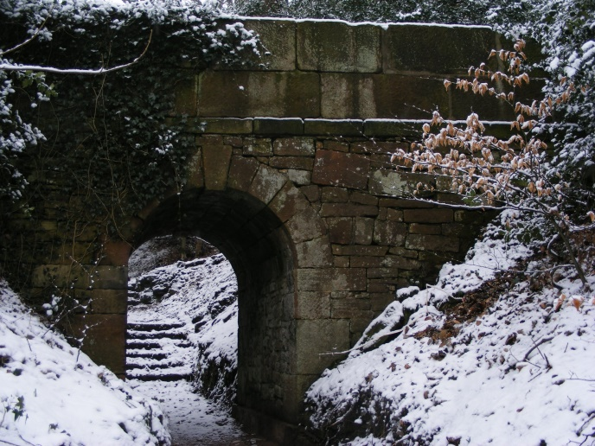  The existing bridge with footpath across the top | 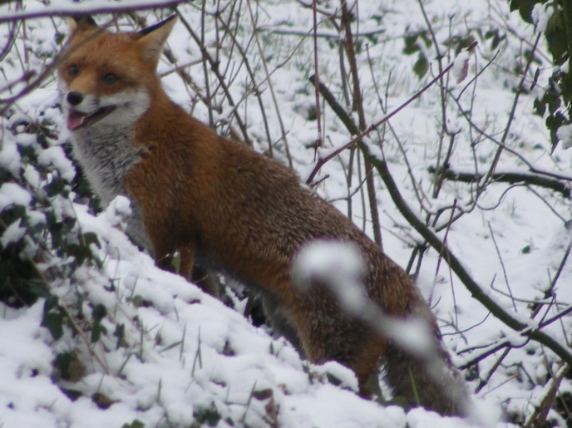  A fox in The Clough
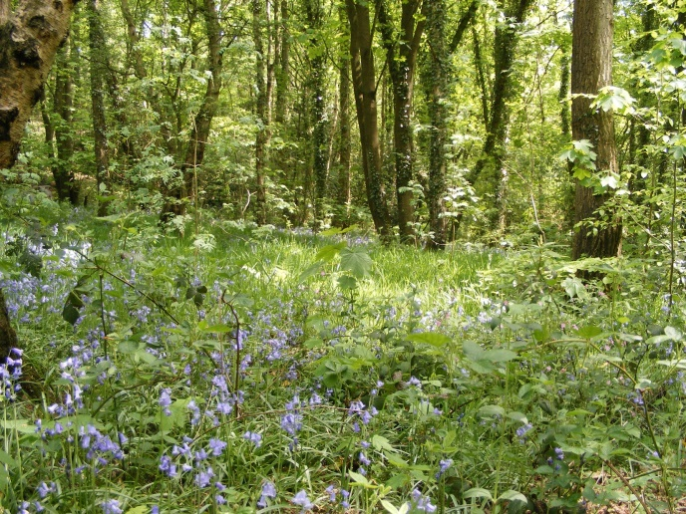 | Blue bells in the spring
Map:

Page 2- The Clough

